A
Project Report
On
Smart Management Information System Portal
Submitted by
Sonakshi Sen [2405101270132]
Krish Bhatt [2405101270168]
Dharmik Kumar Chisla [2405101270031]
as
Partial fulfilment of Semester V
of Bachelors of Computer Applications/ Bachelor of Science in
Information Technology
for A.Y. 2026-2027

Under the Guidance of
Prof. Pritam

Submitted To

Parul Institute of Computer Application,
Faculty of IT & Computer Science
Parul University


Acknowledgement
The success and final outcome of this project required a lot of guidance and assistance from many people and we are extremely privileged to have got this all along the completion of our project. All that we have done is only due to such supervision and assistance and we would not forget to thank them.
I respect and thank Dr. Priya Swaminarayan, Dean, Faculty of IT & Computer Science, for providing us an opportunity to do the project work in BCA/BSCIT/IMCA Regular/Hons and giving us all support and guidance which made us complete the project duly. We are extremely thankful to Mam for providing her support and guidance, although she had a busy schedule managing the academic affairs.
We would not forget to remember Dr. Hina Chokshi, Vice-Principal, for her encouragement and more over for her timely support and guidance till the completion of our project work.
We owe our deep gratitude to our project guide Prof. Pritam, who took keen interest on our project work and guided us all along, till the completion of our project work by providing all the necessary information for developing a good system.
I am thankful to and fortunate enough to get constant encouragement, support and guidance from our Parents, all Teaching staff of the BCA Department which helped us in successfully completing our project work. Also, we would like to extend our sincere esteems to all staff in the laboratory for their timely support.

Sonakshi Sen [2405101270132]
Krish Bhatt [2405101270168]
Dharmik Kumar Chisla [2405101270031]



PARUL INSTITUTE OF COMPUTER APPLICATION

CERTIFICATE

This is to certify that Sonakshi Sen, Krish Bhatt, and Dharmik Kurmar Chisla the students of Parul Institute of Computer Application, have satisfactorily completed the project entitled “Smart Management Information System Portal” as a part of course curriculum in BSC–IT (Hons), BCA & BCA(Hons) semester- V for the academic year 2026-2027 under guidance of Prof. Pritam

Sonakshi Sen [2405101270132]
Krish Bhatt [2405101270168]
Dharmik Kumar Chisla [2405101270031]

Quality of work | Grade | Sign of  Internal guide
Poor / Average / Good /  Excellent | B /B+ / A / A+

Date of submission:

HOD, Vice-Principal,
Prof. Vipul Gamit Dr. Hina Chokshi

Dean,
Dr. Priya Swaminarayan

INDEX
No. | Name | Page.no
1. | Introduction to Project System | 6
2.  2.1  2.2  2.3  2.4  2.5  2.6  2.7  2.8 | System Requirement Specification  Introduction to SRS  Hardware Requirement  Software Requirement  System Users  Description of Users Role  System Modules  Description of Modules  Timeline Chart | 7  7  8  9  10  10  11  12  13
3. | System Flow Diagram | 14
4. | Data Flow Diagram (All the Levels) | 15
5.  5.1 | Use Case Diagram  Use Case Specification | 18  20
6. | Activity Diagram | 22
7. | E-R Diagram | 23
8.  8.1  8.2  8.3 | Data Dictionary  Users & Students Registry  Attendance & Outpass Registry  Project Repository File Inventory | 24  24  25  25
9. | Screenshot of Development Phases of 1 - 4 | 26
10. | Testing | 37
11. | Conclusion | 38
12. | Future Enhancements | 38
13. | References | 39

ABSTRACT
The Parul University SMIS Portal is a comprehensive, institutional-grade academic platform designed to streamline the entire university lifecycle across three stakeholder groups: Students, Faculty, and Academic Administrators. It replaces fragmented legacy portals with a responsive single-page application (SPA) backed by an event-driven Node.js gateway.
The system is built on four core pillars: (1) strict role-based access control (RBAC) with cryptographically segregated namespaces (/student, /faculty, /admin); (2) a deterministic 1-hour inactivity auto sign-out with countdown widget and warning modal; (3) a sub-100ms dual-channel real-time sync pipeline combining WebSockets with the HTML5 BroadcastChannel API; and (4) a high-definition printable grade card workflow featuring the University Crest, security barcode, QR code, and digital signatures.
The backend uses Node.js (v18+) with Express.js 5.x and the ws WebSocket library. The frontend leverages HTML5, Vanilla CSS3 with design tokens, Google Fonts, and modular ES6+ JavaScript. An HTML5 Web Audio API engine synthesizes two-tone chimes for live alerts. The design palette uses PU Primary Maroon (#800020), Gold accents (#D97706), and a Slate Dark Mode base (#0F172A).
The Student Portal offers dashboards, attendance tracking, academic calendars, printable grade cards, fee ledgers, gate pass systems with QR codes, and a grievance helpdesk. The Faculty Portal includes workload KPIs, biometric logs, a capstone guide desk, an hourly attendance console with 1-click broadcast, and an outpass approval desk. The Admin Portal delivers executive analytics, registration verification, a 1-click semester result publishing engine (UGC 10-point scale), and a real-time audit log stream.
The system is pre-seeded with six students, five faculty, and one administrator, all accessible via password password123. Setup requires only Node.js v18+ and a browser, running via npm install and npm start at http://localhost:3000. Four verification tests cover multi-tab attendance sync, outpass approval with QR gatepass, the 1-hour idle timeout, and result publishing with grade card printing.

Keywords: Enterprise Resource Planning, Academic Management System, Real-Time Synchronization, WebSocket, BroadcastChannel API, RBAC, Inactivity Timeout, Grade Card Generation, Node.js, Express.js, SPA, UGC 10-Point Scale, QR Code Verification, Audit Logging.

1. INTRODUCTION TO PROJECT SYSTEM

Higher education institutions routinely operate across fragmented software solutions for attendance, grading, hostel gate passes, and fee reconciliation. This fragmentation leads to operational bottlenecks, manual record discrepancies, and delays in student support services.
The proposed Smart Management Information System Portal (Parul University ERP Enterprise System) provides a centralized, institutional-grade academic enterprise platform. It streamlines operations across three core academic stakeholders: Students, Faculty Instructors, and Academic Administrators within a single responsive web interface.
The architecture combines a modern single-page application frontend with an event-driven Node.js and Express.js backend. A dual-channel real-time pipeline (WebSockets and the HTML5 BroadcastChannel API) provides immediate sub-100ms synchronization across all stakeholders, enabling live attendance updates, hostel outpass review, and grade transcript publishing. Furthermore, strict Role-Based Access Control (RBAC) and deterministic 1-hour session inactivity auto-logout ensure full institutional terminal security compliance.

2. System Requirement Specification

2.1 Introduction to SRS
The System Requirement Specification (SRS) details the operational capabilities, architectural constraints, and resource prerequisites for deploying the Smart Management Information System Portal.
Feasibility Study

Type | Description
Technical | Built using HTML5, modular CSS3, Vanilla ES6+ JavaScript, Node.js, Express.js 5.x, WebSockets, and in-memory persistent JSON stores. Graceful fallback ensures offline functionality.
Economic | Developed entirely on open-source web standards with zero recurring third-party commercial licensing costs.
Operational | Clean, responsive UI with dedicated role portals (/student, /faculty, /admin) requiring no advanced training for students or university staff.
Schedule | Modular implementation planned and executed across seven development phases within the academic semester.
Legal / Compliance | Incorporates ISO/IEC 27001 data isolation practices, role-segregated namespaces, and 60-minute automatic idle sign-out to safeguard terminal sessions.

2.2 Hardware Requirement

Component | Minimum Requirement | Recommended Specification
Processor | Dual-Core Intel Core i3 or AMD equivalent | Quad-Core Intel Core i5 / AMD Ryzen 5 or higher
RAM | 4 GB RAM minimum | 8 GB RAM or higher
Storage | 5 GB available disk space | 10 GB SSD storage
Display | 1366 × 768 standard resolution | 1920 × 1080 Full HD
Input | Keyboard, standard mouse, or touch interface | Standard workstation peripherals
Network | Localhost or Local Area Network (LAN) | Broadband connection for multi-device sync

2.3 Software Requirement
Technology | Role & Purpose
Operating System | Windows 10/11, macOS, or Linux (Ubuntu/Debian)
Runtime Engine | Node.js (Version 18.0.0 or higher)
Backend Framework | Express.js 5.x (HTTP REST API and asset hosting)
Real-Time Engine | WebSocket Server (ws library v8.21.3) + HTML5 BroadcastChannel API
Audio Engine | HTML5 Web Audio API (Synthesized live event chimes: C5 to E5)
Frontend Core | Semantic HTML5, Vanilla CSS3 (Custom Properties), ES6+ JavaScript
Web Browser | Google Chrome 90+, Microsoft Edge 90+, Mozilla Firefox 88+, Safari 14+
Development Tools | Visual Studio Code, Git, Postman / Browser DevTools
Technology | Role & Purpose
Operating System | Windows 10/11, macOS, or Linux (Ubuntu/Debian)

2.4 System Users

- Student: Views academic standing, hourly schedules, subject-wise attendance, fee statements, applies for hostel outpasses, and downloads official PDF Grade Cards.
- Faculty: Records hourly classroom attendance, manages supervised Capstone project groups, evaluates CIE/Mid-Sem scores, and reviews hostel leave outpasses.
- Administrator: Manages user rosters, configures departments and curriculum, triggers the Result Publishing Engine, and monitors the live CDC System Audit stream.

2.5 Description of User Role

Role | Main Activities
Student | Authentication, track lecture compliance ($≥75\%$), submit outpass requests, inspect mess passes, view marks, print official Grade Cards.
Faculty | Hourly batch attendance entry, capstone project tracking, marks entry, review and approve/reject student outpasses.
Administrator | Master enrolment governance, verification of new sign-ups, result computation, real-time audit ledger inspection

2.6 System Modules
- Central Authentication & Role-Based Access Control (RBAC)
- 1-Hour Inactivity Auto Sign-Out Engine
- Dual-Channel Real-Time Data Bus (WebSockets + BroadcastChannel)
- Student Academic Dashboard & Attendance Tracker
- Hostel Gate Pass & Digital QR Clearance Module
- Faculty Attendance Console & Capstone Guide Desk
- Administrative Result Publishing & Examination Engine
- Client-Side Printable Grade Card PDF Pipeline
- Real-Time CDC System Audit Ledger

2.7 Description of Modules
Module | Description
Central Auth & RBAC | Segregates sessions into /student, /faculty, and /admin namespaces using Enrollment numbers, Employee IDs, and Admin IDs.
1-Hour Idle Timeout | Tracks passive user events; triggers an alert modal at 55 minutes and wipes credentials at 60 minutes.
Real-Time Data Bus | Distributes live academic updates across active sessions with Web Audio chime synthesis.
Attendance Tracker | Aggregates subject compliance dynamically and alerts users if attendance drops below 75%.
Hostel Outpass & QR | Handles student outpass applications; approval generates an instant verifiable QR Gatepass.
Faculty Console | Provides batch attendance tools ("Mark All Present/Absent") and capstone review management.
Result Publishing | Aggregates CIE, Mid-Sem, and End-Sem scores to compute SGPA and CGPA per UGC standards.
Printable Grade Card | Renders high-definition marksheets complete with university crest, security barcode, and QR code.
System Audit Stream | Live Change-Data-Capture (CDC) ledger tracking actor actions, timestamps, and IP addresses.

2.8 Timeline Chart
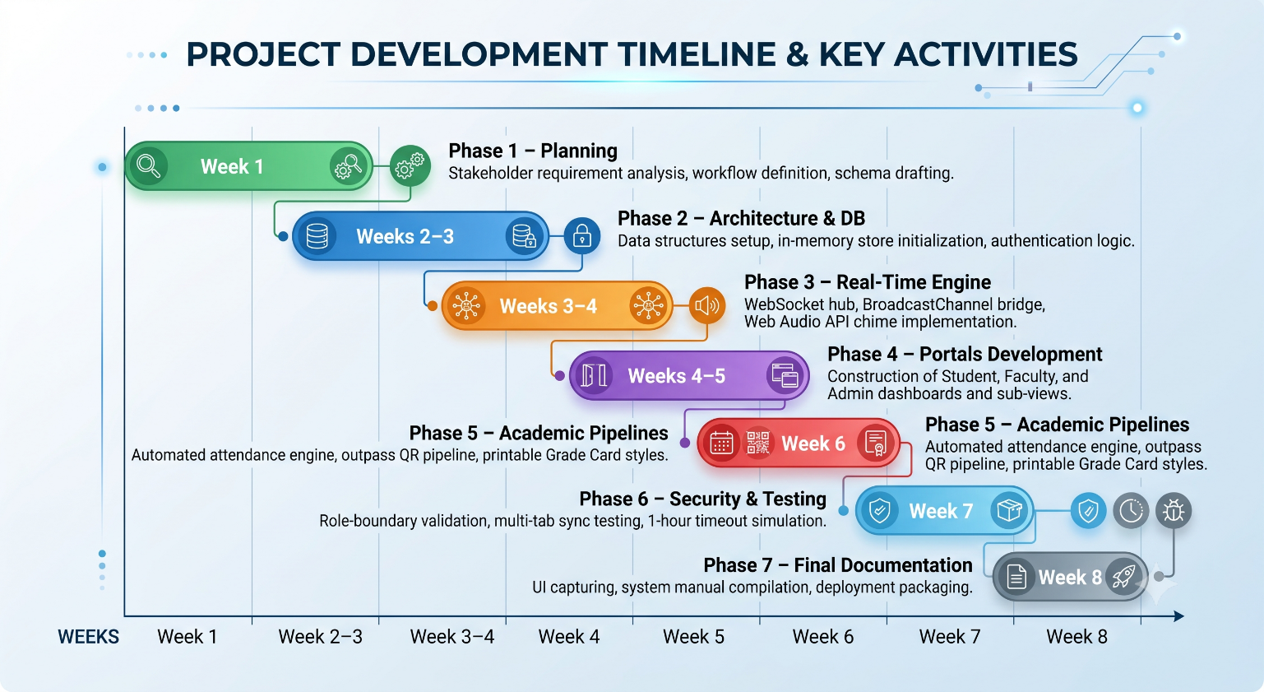

3. SYSTEM FLOW DIAGRAM
The system initiates at the central authentication gateway. Upon successful login, users are routed strictly to their designated portal. When a faculty member records attendance or an administrator publishes marks, an event is dispatched to the dual-channel data bus. Connected student views update dynamically without requiring page refreshes. Simultaneously, an inactivity monitor tracks terminal interactions, prompting a session reset if 60 minutes of inactivity elapse.
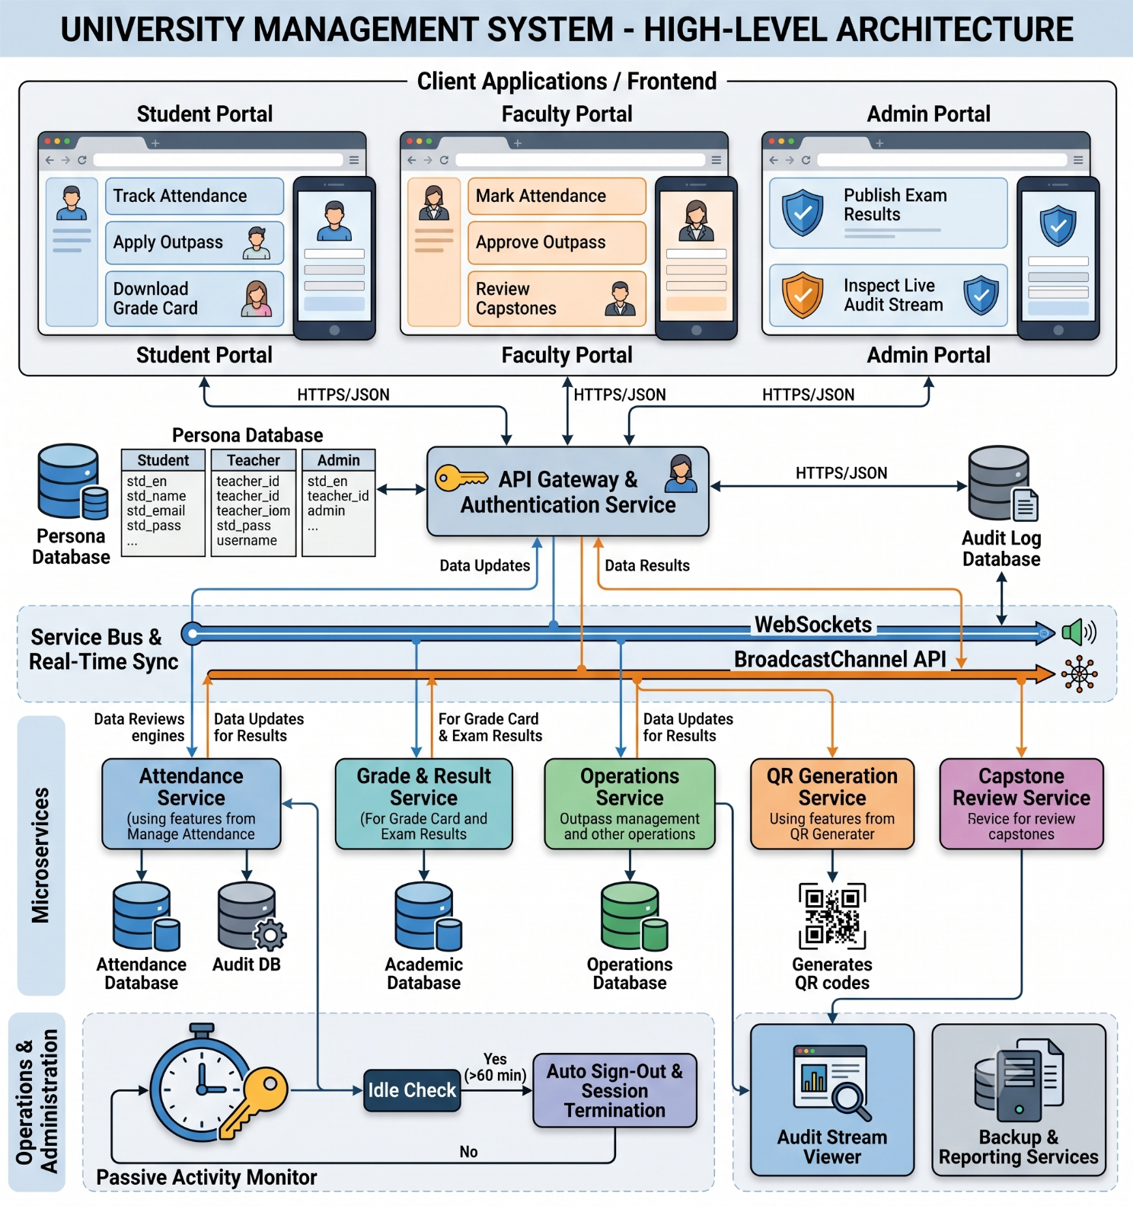
4. DATA FLOW DIAGRAMS

4.1 DFD Level 0 – Context Level

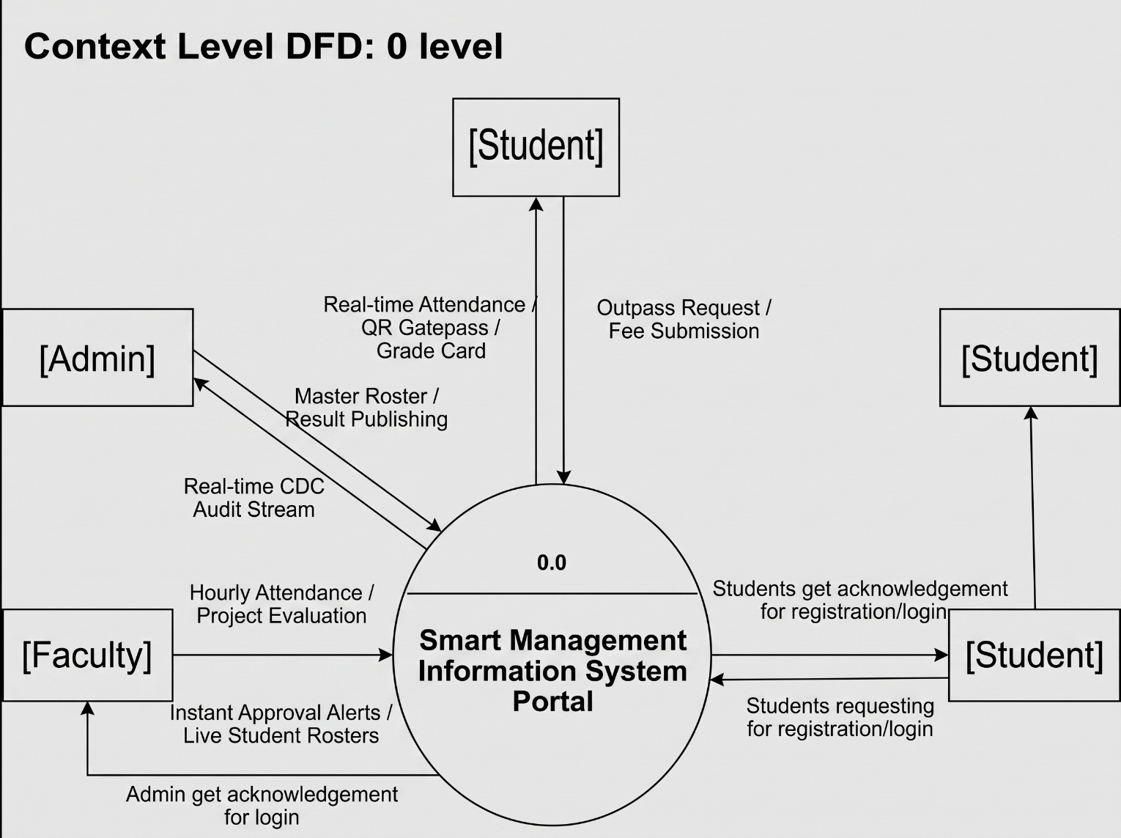

4.2 DFD Level 1 – Operational Subsystems

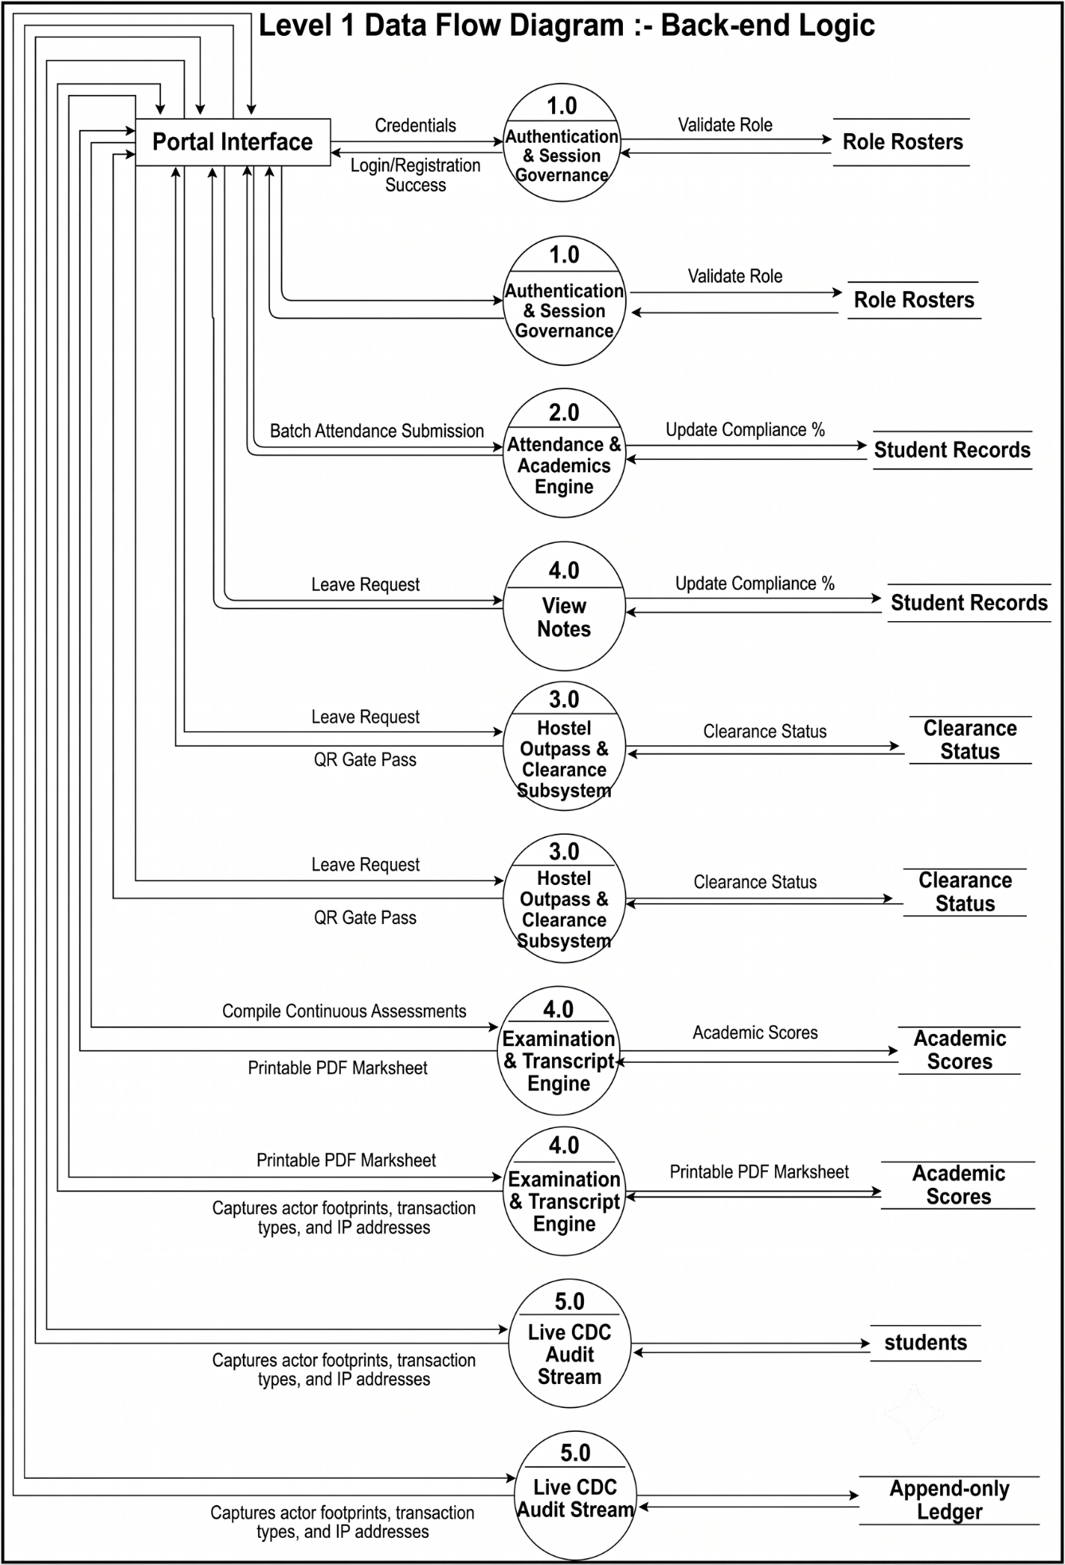
4.3 DFD Level 2 – Attendance & Outpass Processing

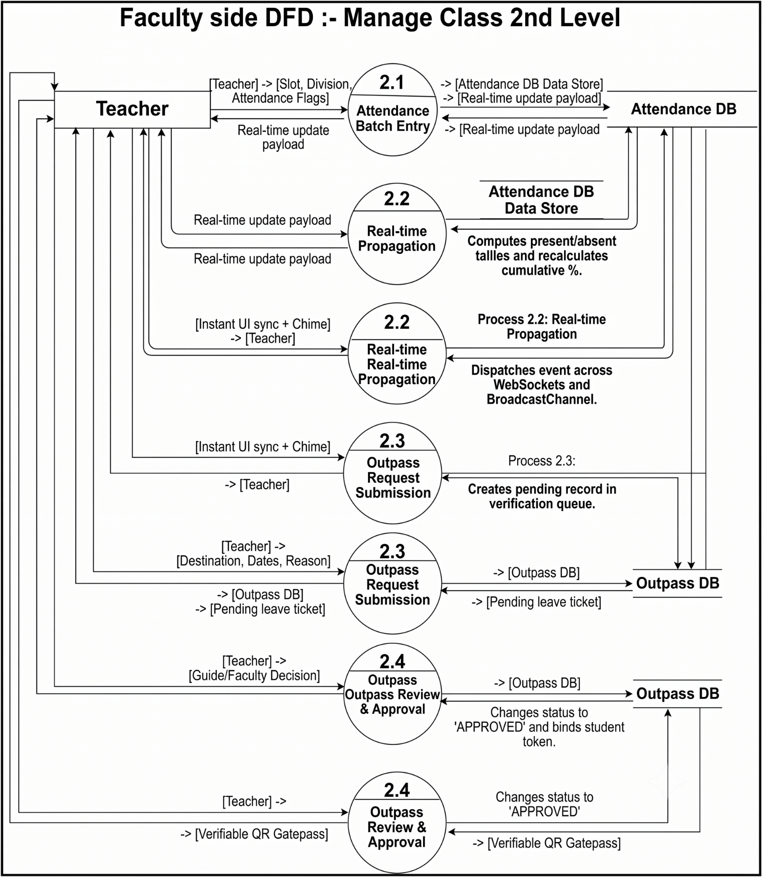

5. USE CASE DIAGRAM

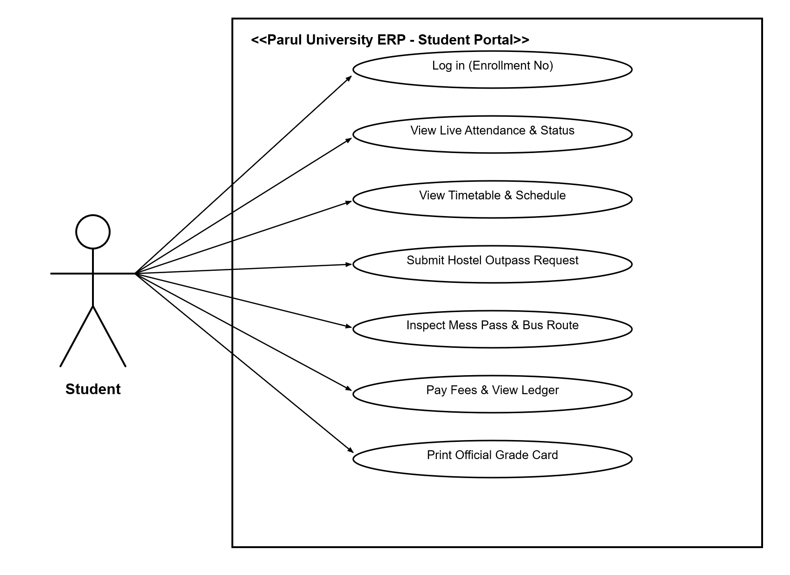
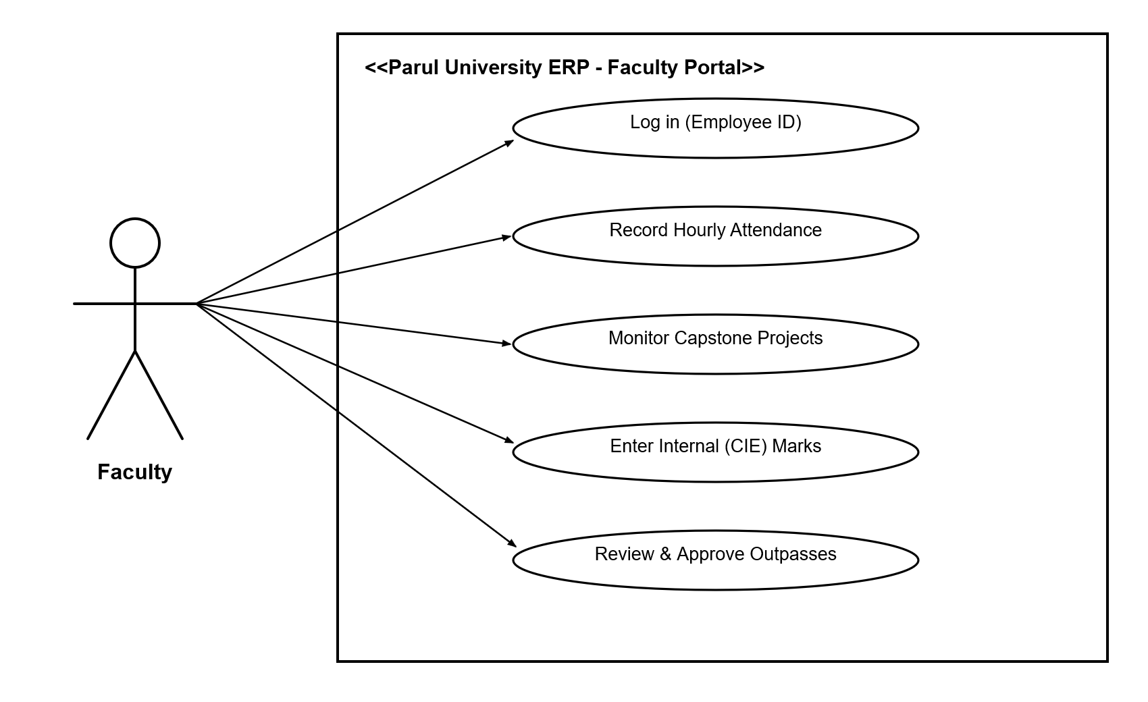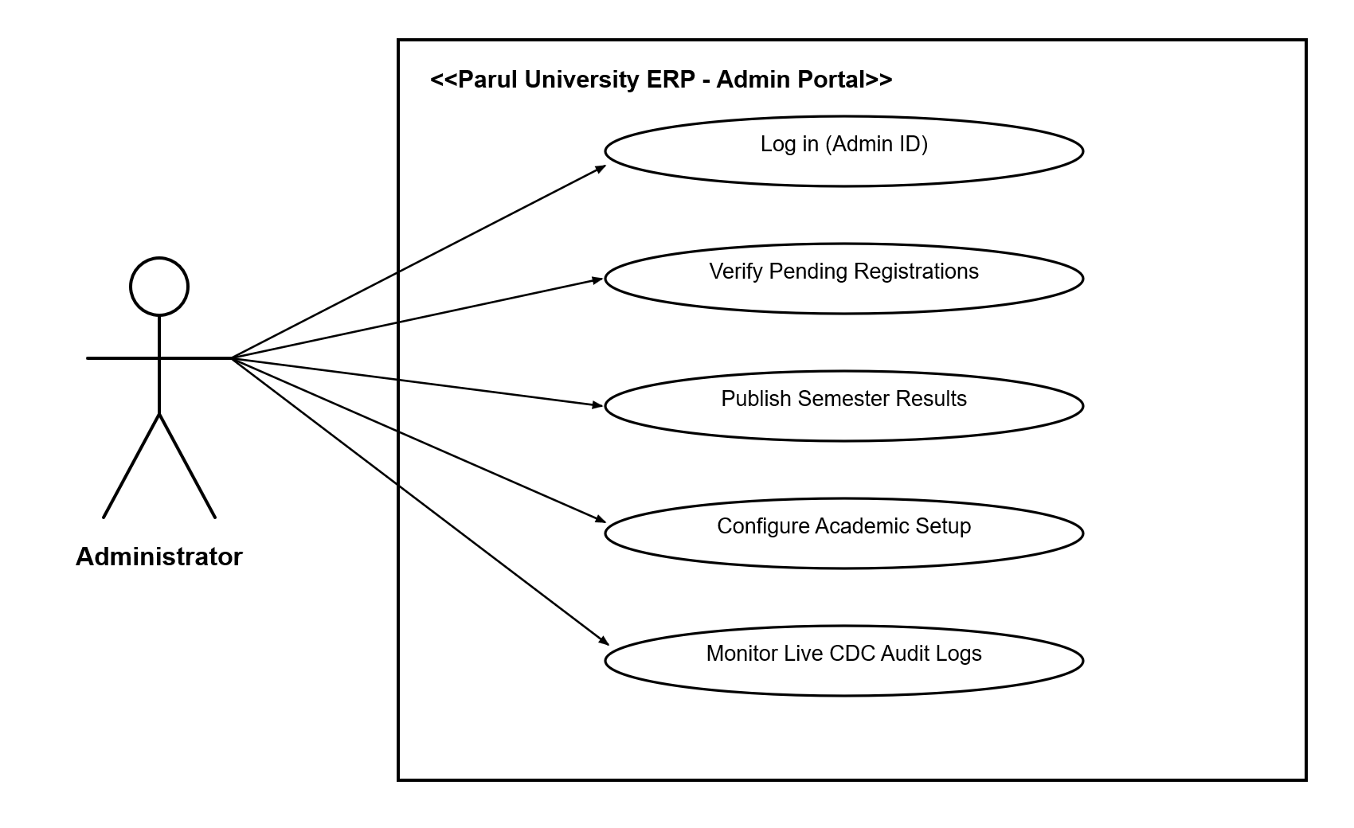
Fig 5 – Use Case Diagram
• Student Actor: Log in via Enrollment Number, view live attendance and compliance statuses, view timetable, submit hostel outpass applications, inspect mess card, pay fees, and print official Grade Cards.
• Faculty Actor: Log in via Employee ID, record hourly attendance via batch toggles, monitor Capstone groups, enter internal marks, and approve/reject hostel outpass requests.
• Administrator Actor: Log in via Admin ID, verify pending registrations, publish end-semester results, configure academic frameworks, and monitor the live CDC audit ledger.

5.1 Use Case Specifications
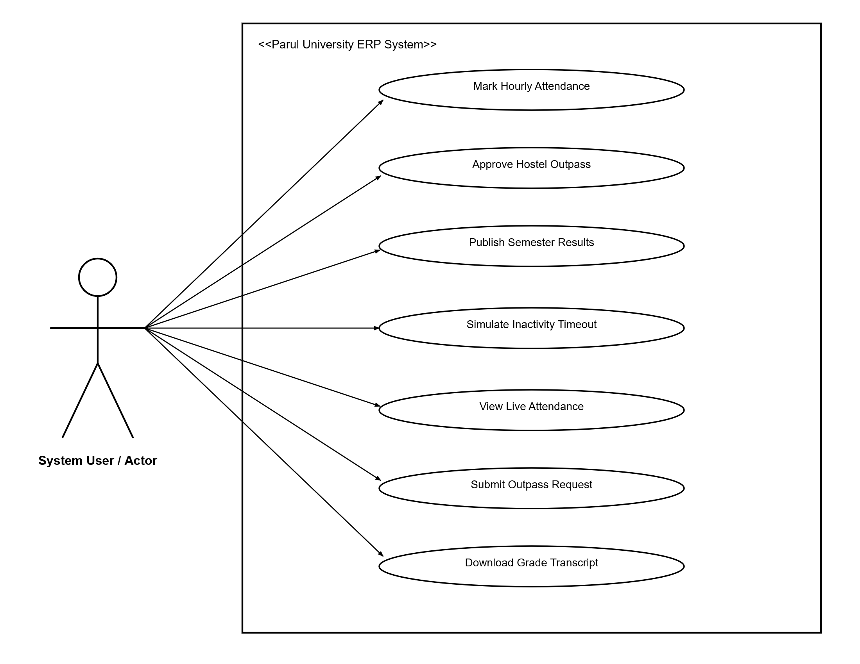
Use Case | Primary Actor | Pre-condition | Post-condition
Mark Hourly Attendance | Faculty | Active session, assigned course slot | Roster updated, CDC logged, student notified
Approve Hostel Outpass | Faculty | Outpass submitted and pending | Student view unlocks verified QR Gatepass
Publish Semester Results | Admin | Internal and End-Sem scores entered | System computes SGPA/CGPA; unlocks Grade Cards
Download Grade Transcript | Student | Results published by Administrator | Renders official printable marksheet PDF
Simulate Inactivity Timeout | Any Role | Active authenticated session | Session tokens wiped; redirected to alert banner

6. ACTIVITY DIAGRAM

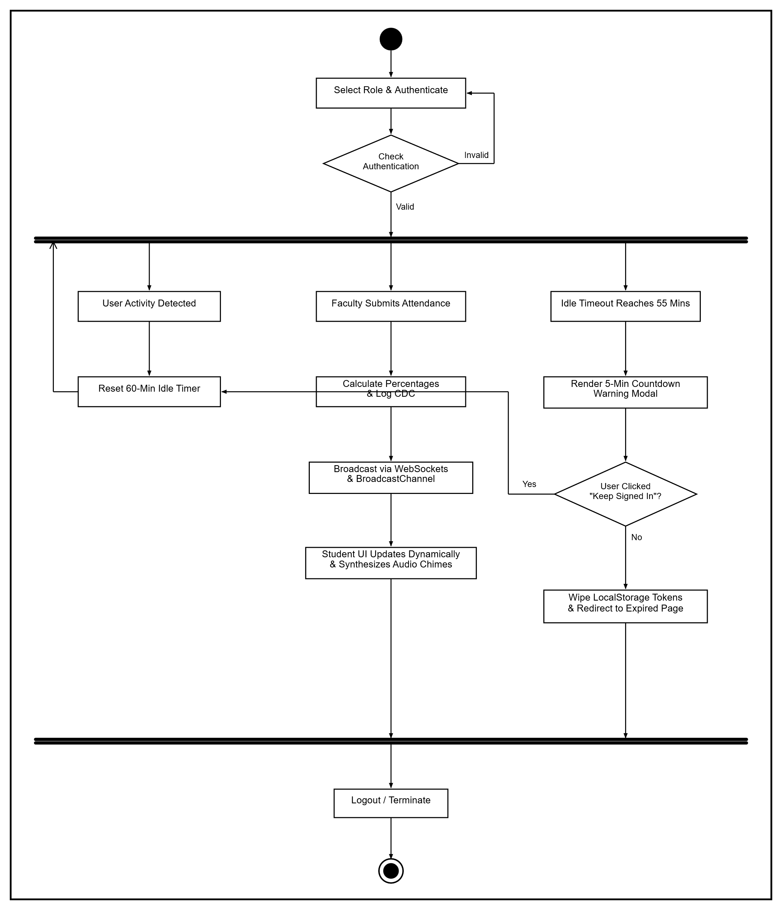

7.E-R Diagram
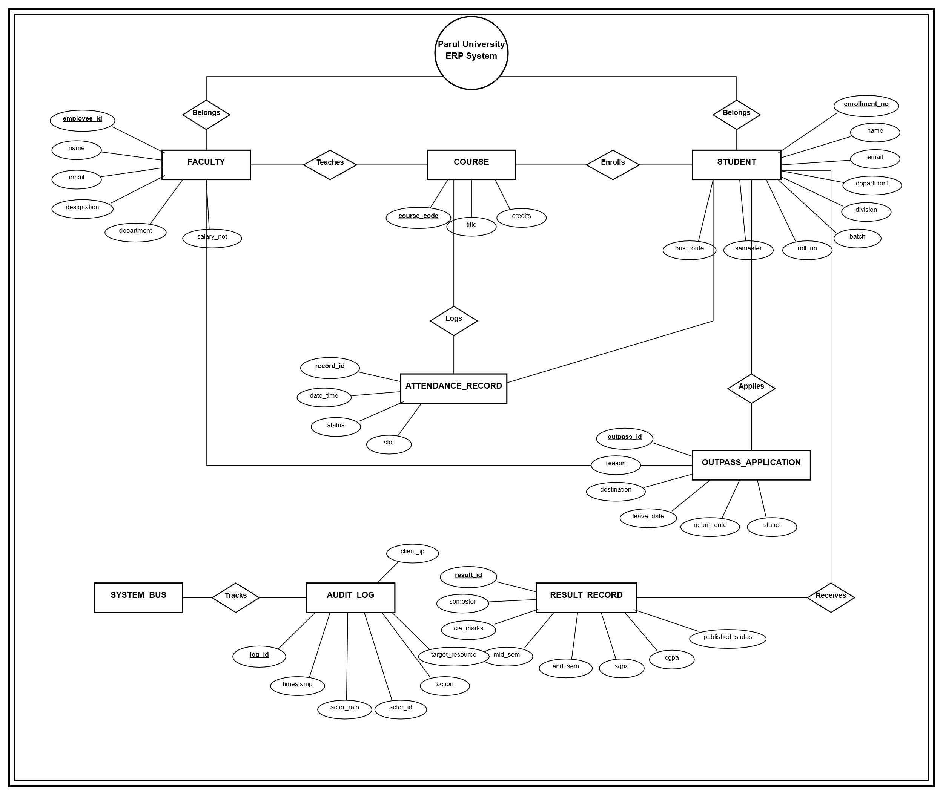

- Entities (Rectangles):
- STUDENT
- FACULTY
- COURSE
- ATTENDANCE_RECORD
- OUTPASS_APPLICATION
- RESULT_RECORD
- AUDIT_LOG
- SYSTEM_BUS

- Relationships (Diamonds):
- Belongs: Connects top system circle to master entities (STUDENT, FACULTY)
- Teaches: FACULTY (1) $→$ COURSE (M)
- Enrolls: STUDENT (M) $→$ COURSE (N)
- Logs: COURSE (1) $→$ ATTENDANCE_RECORD (M)
- Applies: STUDENT (1) $→$ OUTPASS_APPLICATION (M)
- Approves: FACULTY (1) $→$ OUTPASS_APPLICATION (M)
- Receives: STUDENT (1) $→$ RESULT_RECORD (M)
- Tracks: SYSTEM_BUS $→$ AUDIT_LOG

- Primary Keys (Underlined Attributes):
- enrollment_no
- employee_id
- course_code
- record_id
- outpass_id
- result_id
- log_id

8. DATA DICTIONARY

8.1 USERS & STUDENTS REGISTRY

Field | Data Type | Constraint | Description
enrollment_no | VARCHAR(12) | PRIMARY KEY | Unique 12-digit university student identifier
full_name | VARCHAR(100) | NOT NULL | Official student name
email | VARCHAR(100) | UNIQUE, NOT NULL | Institutional communication email
program_name | VARCHAR(80) | NOT NULL | Degree branch (e.g., B.Tech CSE)
division | VARCHAR(5) | NOT NULL | Academic division (e.g., 6A, 6B)
overall_att | DECIMAL(5,2) | DEFAULT 0.00 | Aggregate attendance compliance percentage

8.2 ATTENDANCE AND OUTPASS REGISTRY

Field | Data Type | Constraint | Description
attendance_id | BIGINT | PRIMARY KEY | Unique attendance entry identifier
course_code | VARCHAR(10) | NOT NULL | Academic subject code (e.g., CS601)
status | ENUM | P, A, L | Present, Absent, or Late status flag
outpass_id | BIGINT | PRIMARY KEY | Unique hostel outpass ticket ID
qr_token | TEXT | NULL | Cryptographic token for security gate clearance
approval_stat | ENUM | PENDING, APPROVED, REJECTED | Status of the submitted outpass

8.3 PROJECT REPOSITORY FILE INVENTORY

File Name | Purpose
server.js | Express.js 5.x server setup, HTTP routes, and WebSocket hub.
public/index.html | Single-page application shell, role modals, and topbars.
public/js/auth.js | RBAC governance, session tokens, and 1-hour inactivity monitor.
public/js/realtime.js | Real-time WebSocket pub/sub engine and audio synthesizer.
public/js/student-portal.js | Student UI controllers, attendance gauges, and Grade Card generator.
public/js/faculty-portal.js | Faculty attendance console, capstone desk, and outpass approvals.
public/js/admin-portal.js | Result Publishing Engine, registration queue, and live CDC logs.

9. SCREENSHOTS OF DEVELOPMENT PHASE – 1 to 4
(Place the actual user interface screenshots from the live application here):
- Fig 9.1: Central Split-Screen Authentication Portal (Featuring persona tabs for Student, Faculty, and Admin). 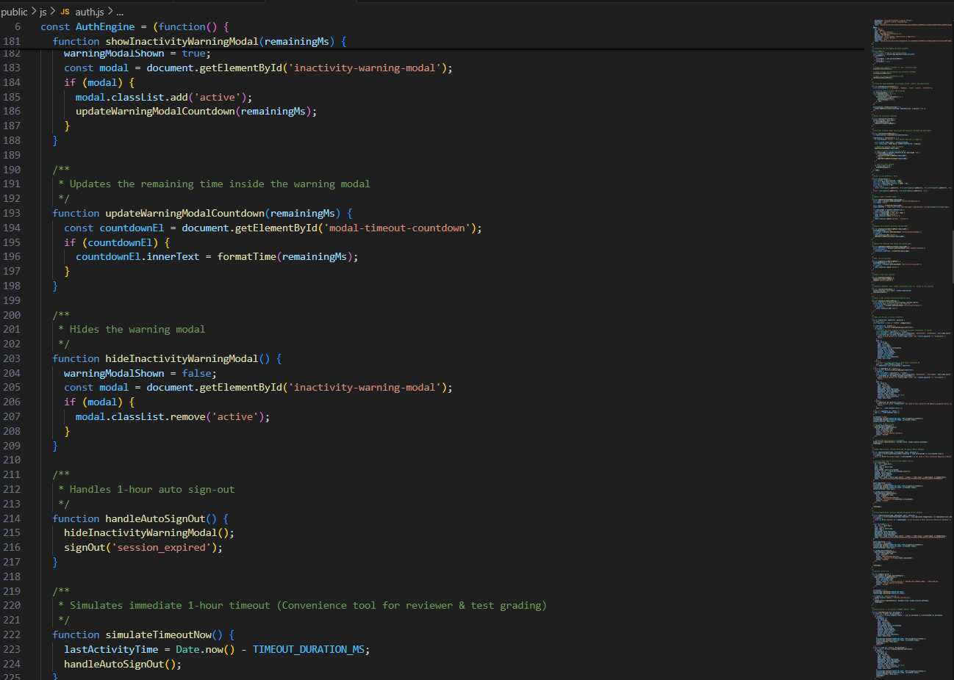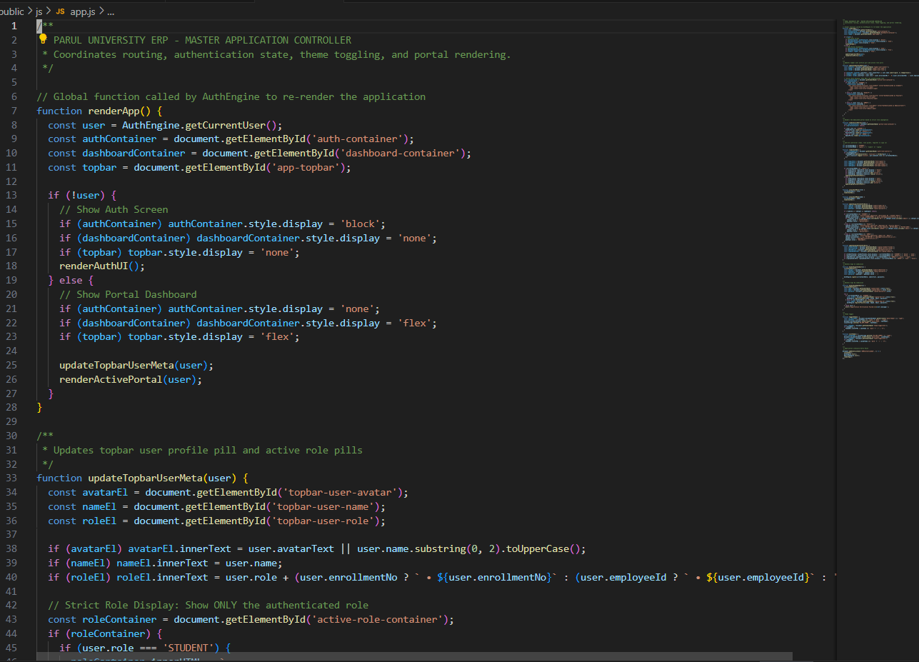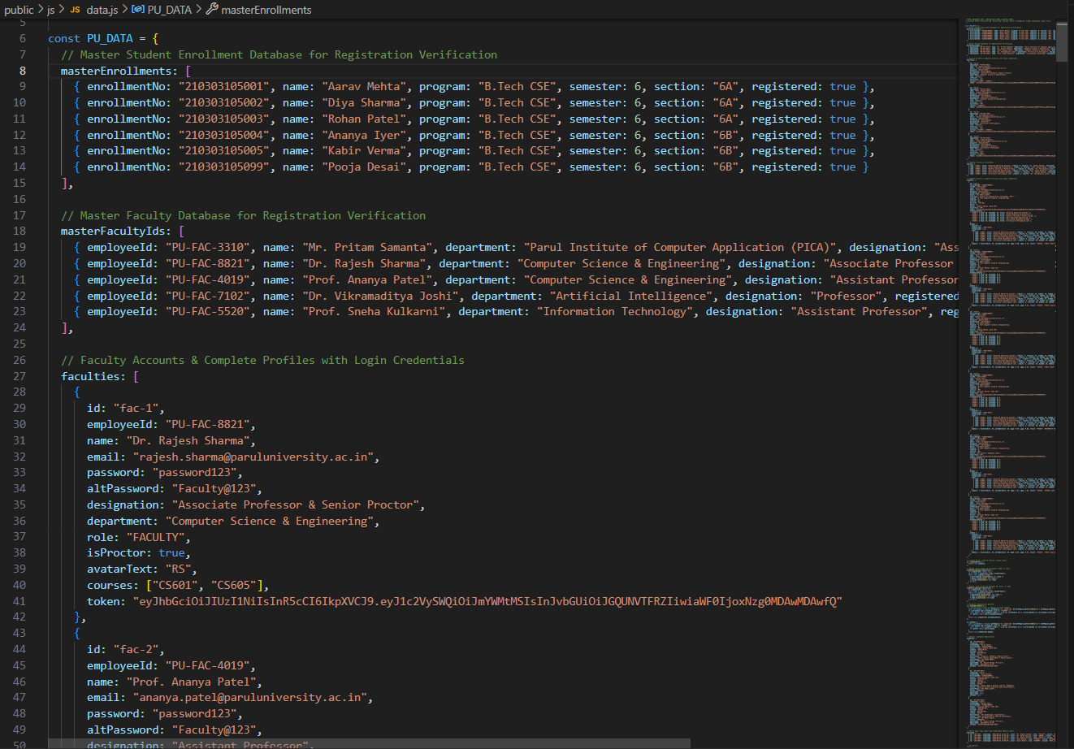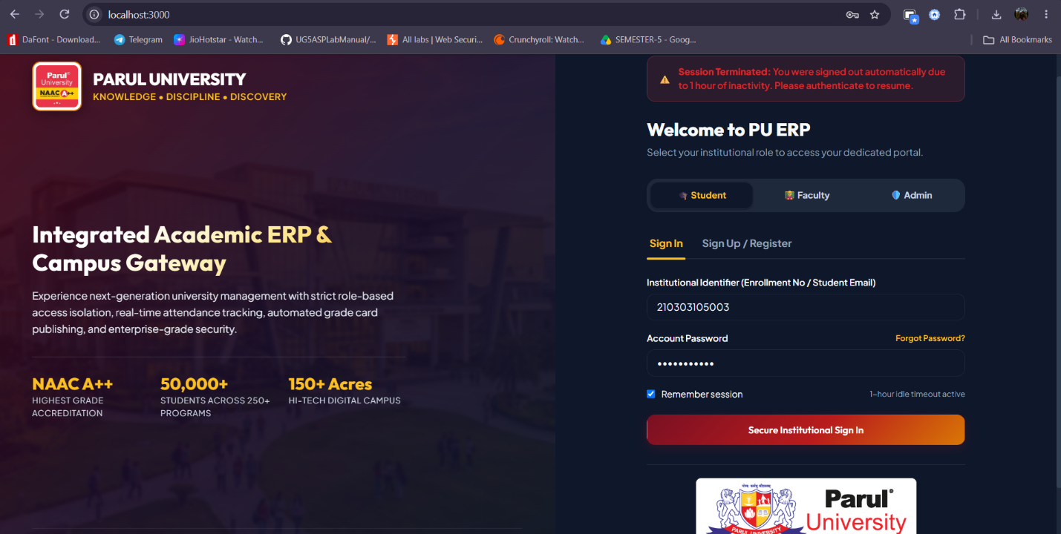

- Fig 9.2: Student Dashboard & Visual Attendance Compliance Gauge (Highlighting attendance percentages and today's timetable).
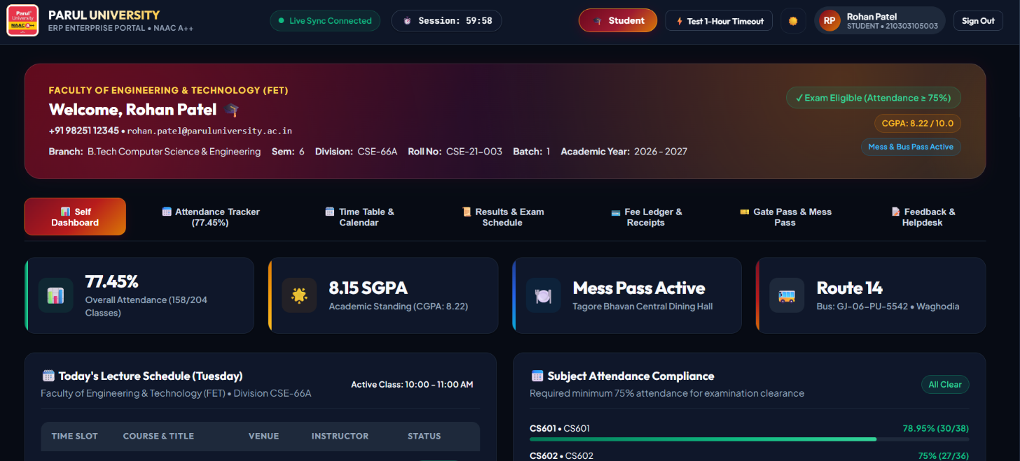
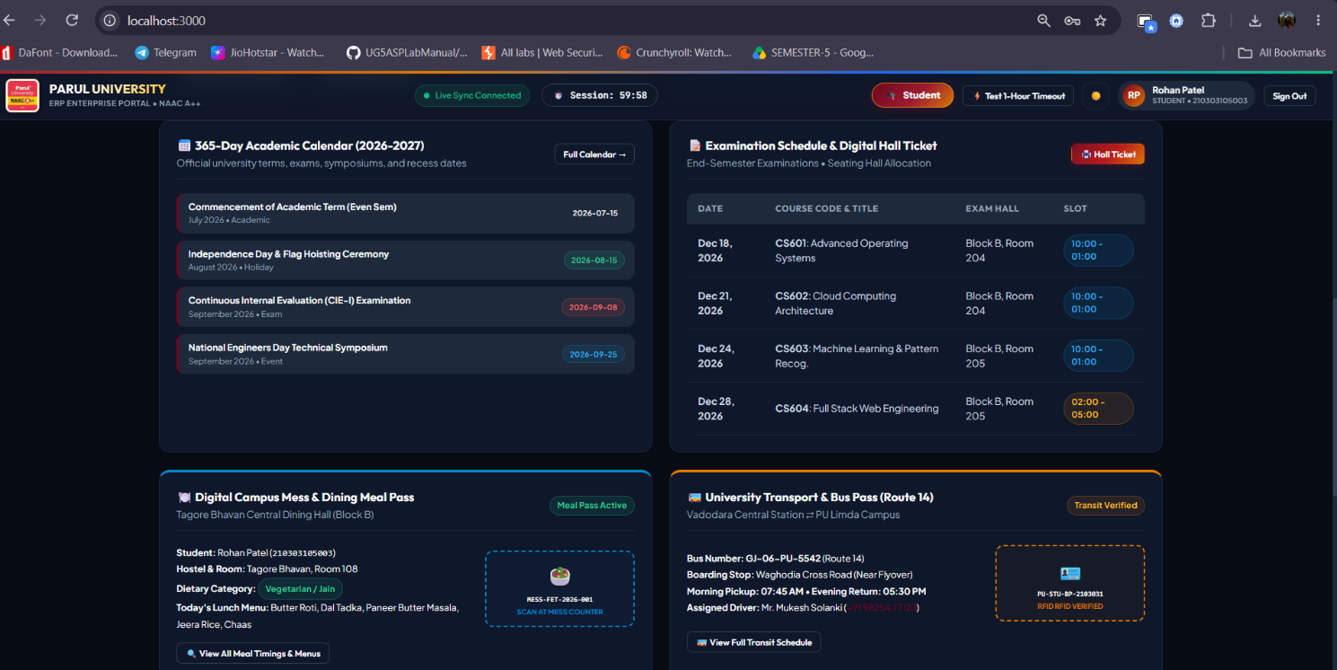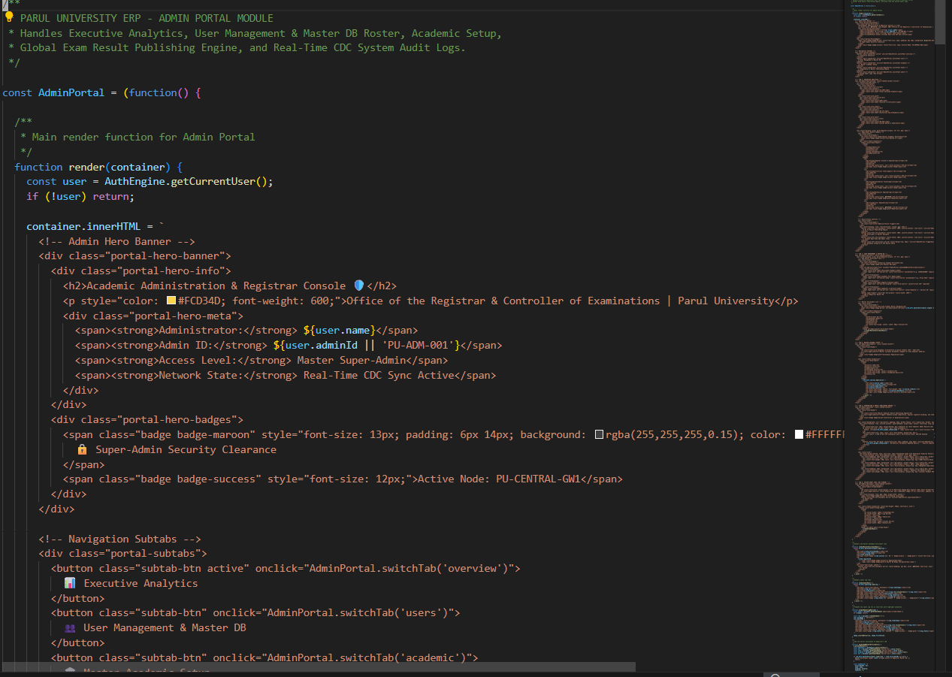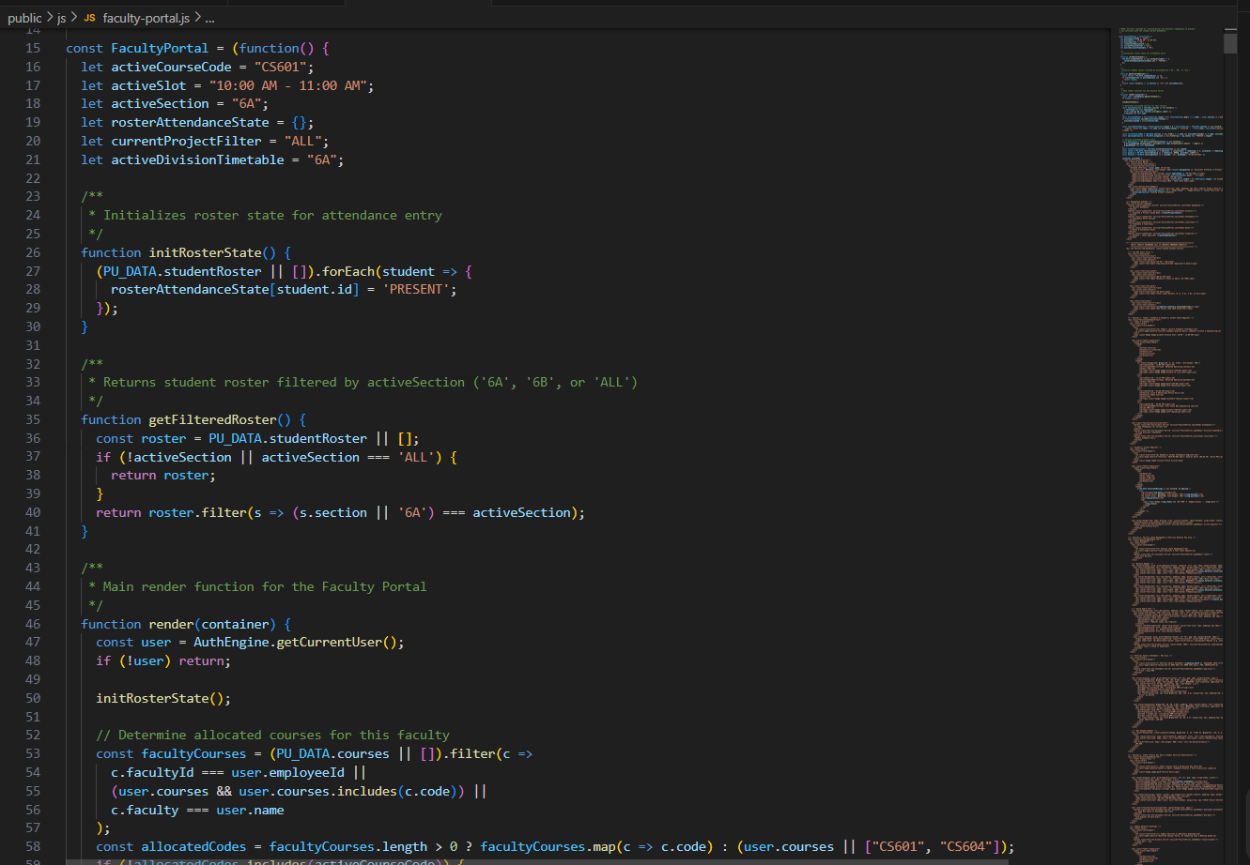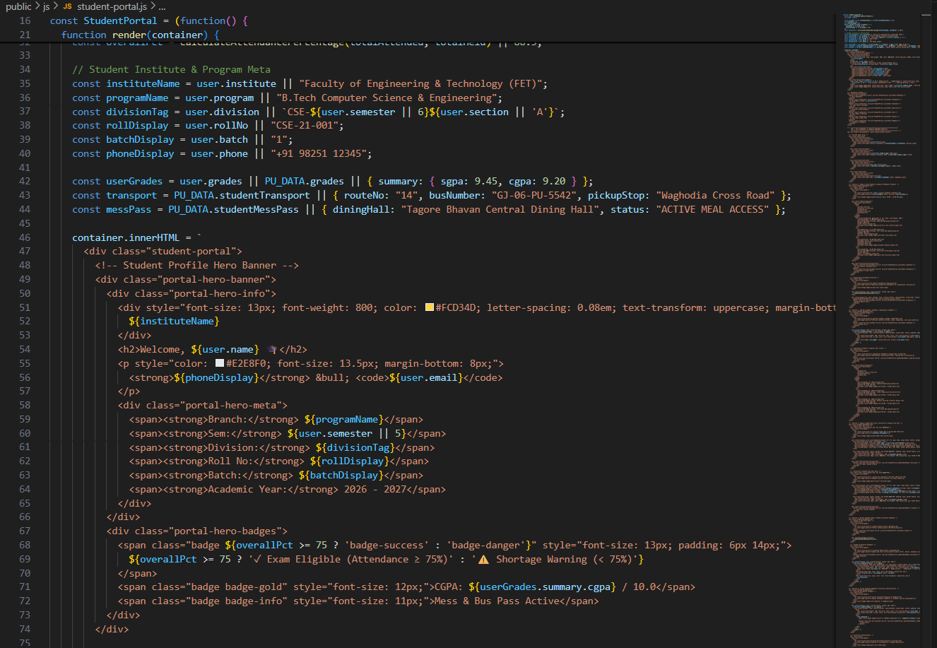
- Fig 9.3: Faculty Hourly Attendance Entry Console (With "Mark All Present/Absent" toggles and instant WebSocket broadcast).
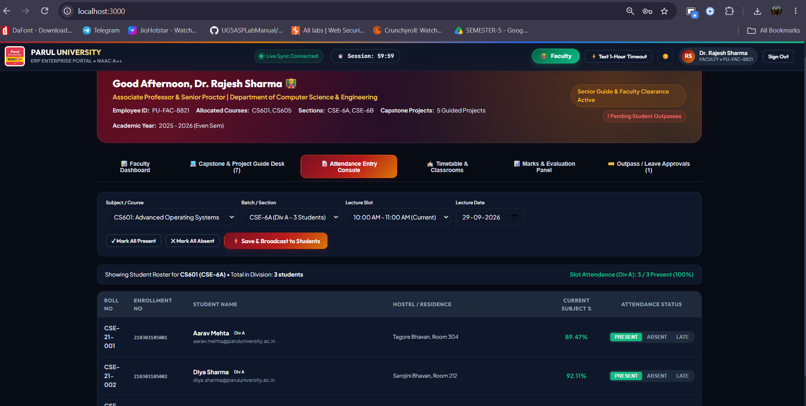
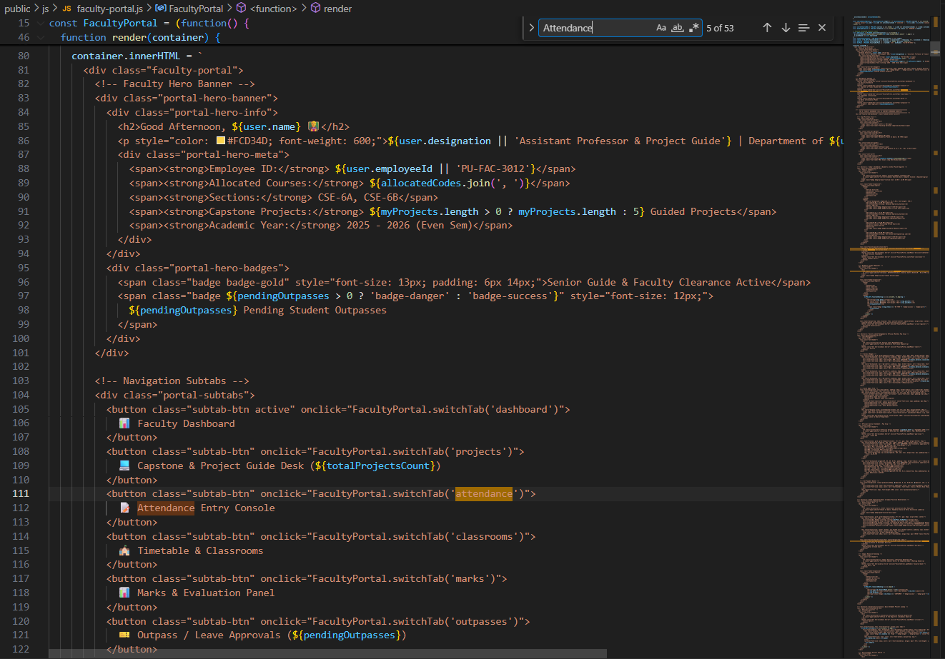
- Fig 9.4: Real-Time Hostel Outpass Review & Generated Digital QR Gatepass. 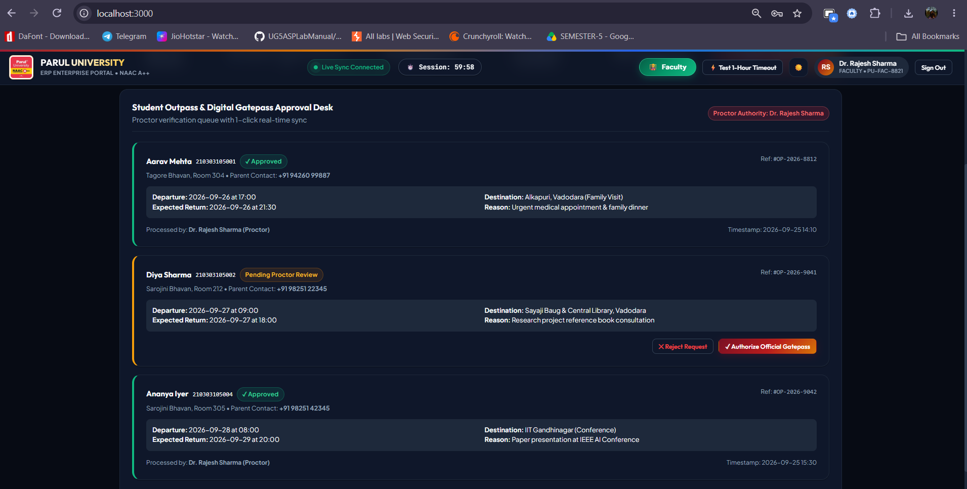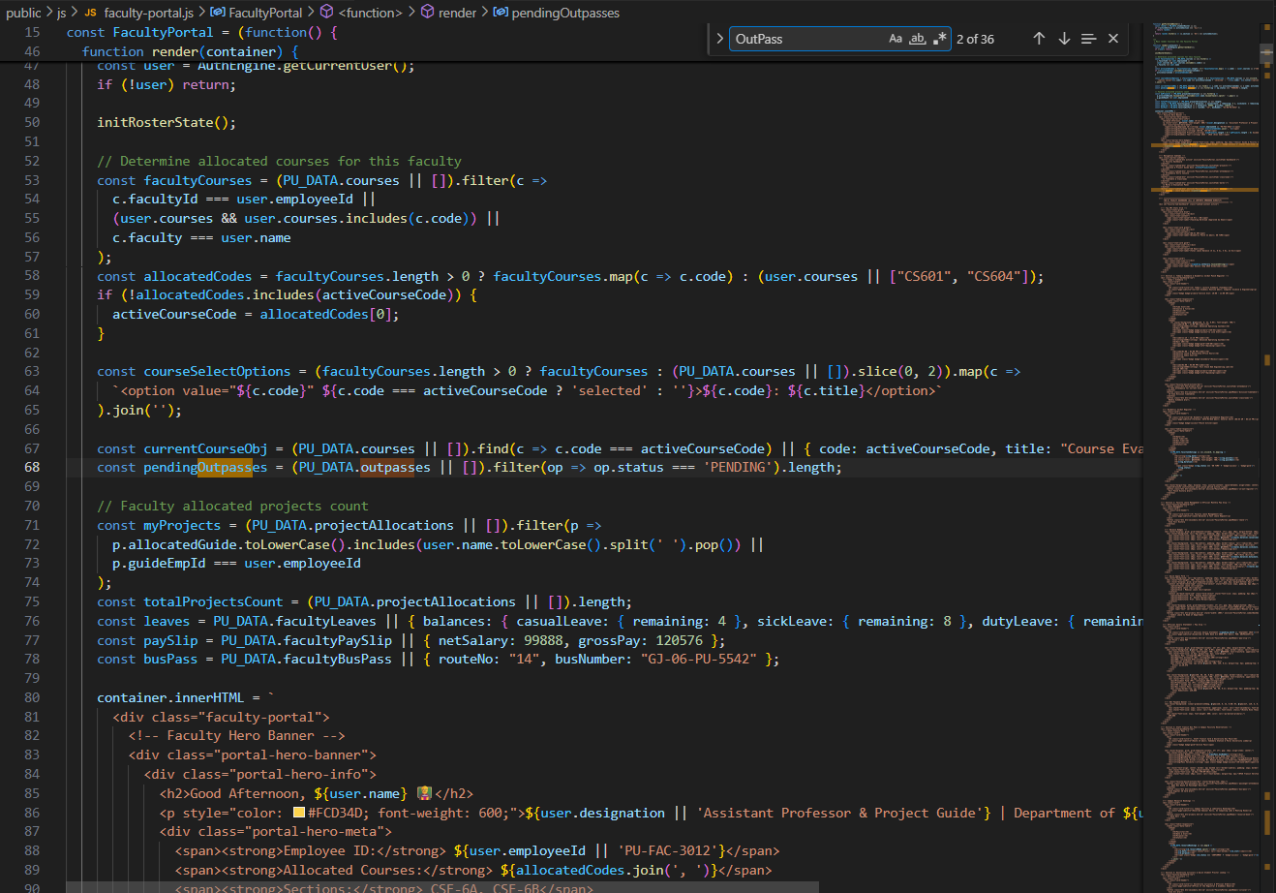
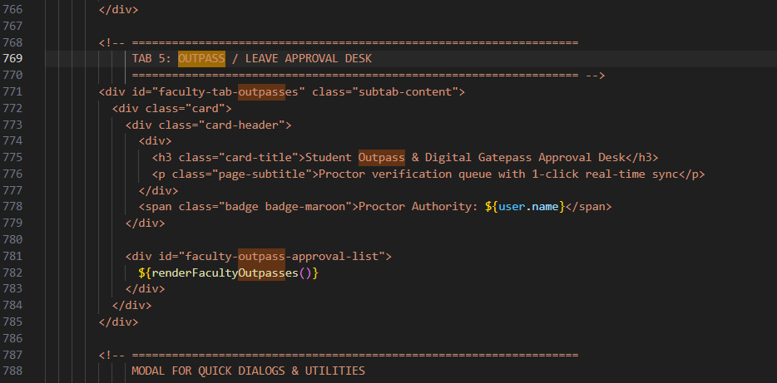
- Fig 9.5: Administrative Result Publishing Console & Live CDC Audit Stream.
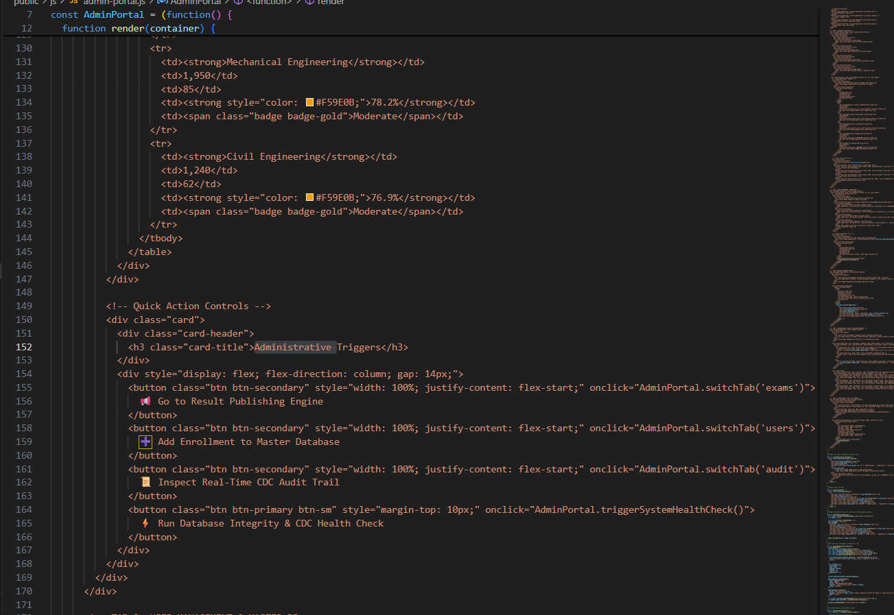
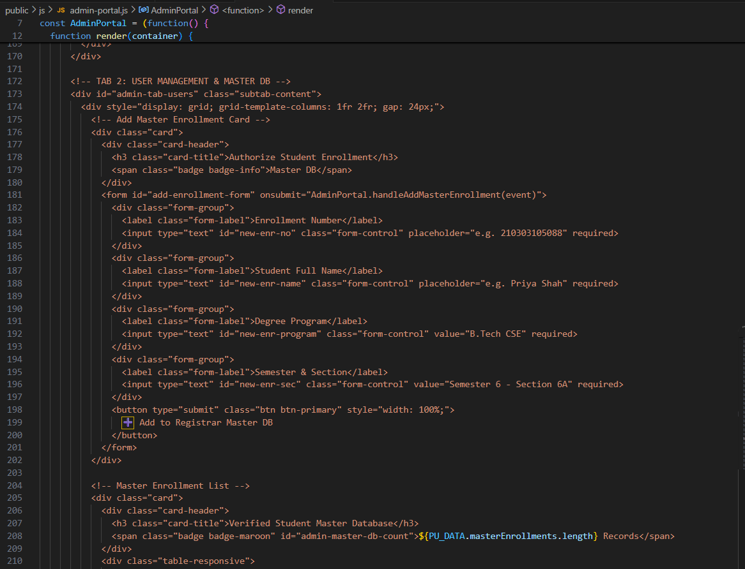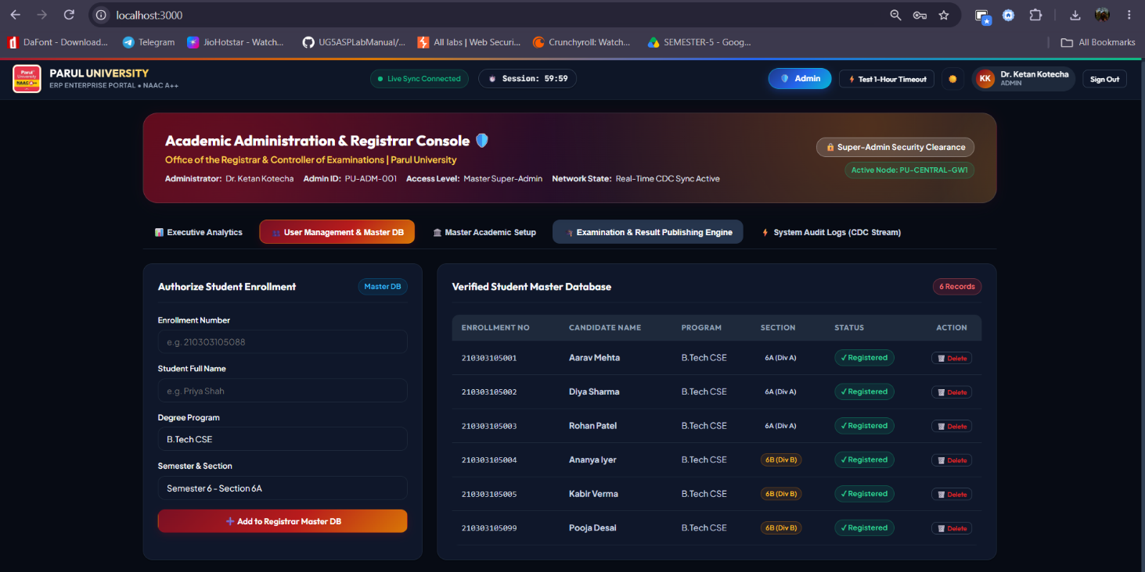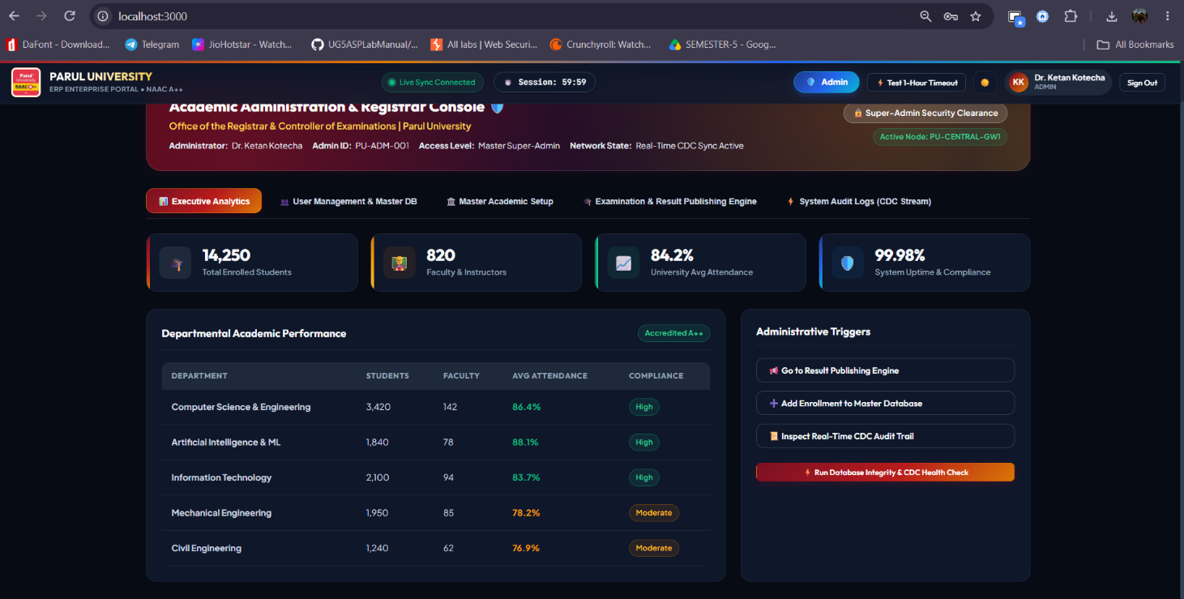
- Fig 10.6: Official Printable Parul University Grade Transcript PDF Modal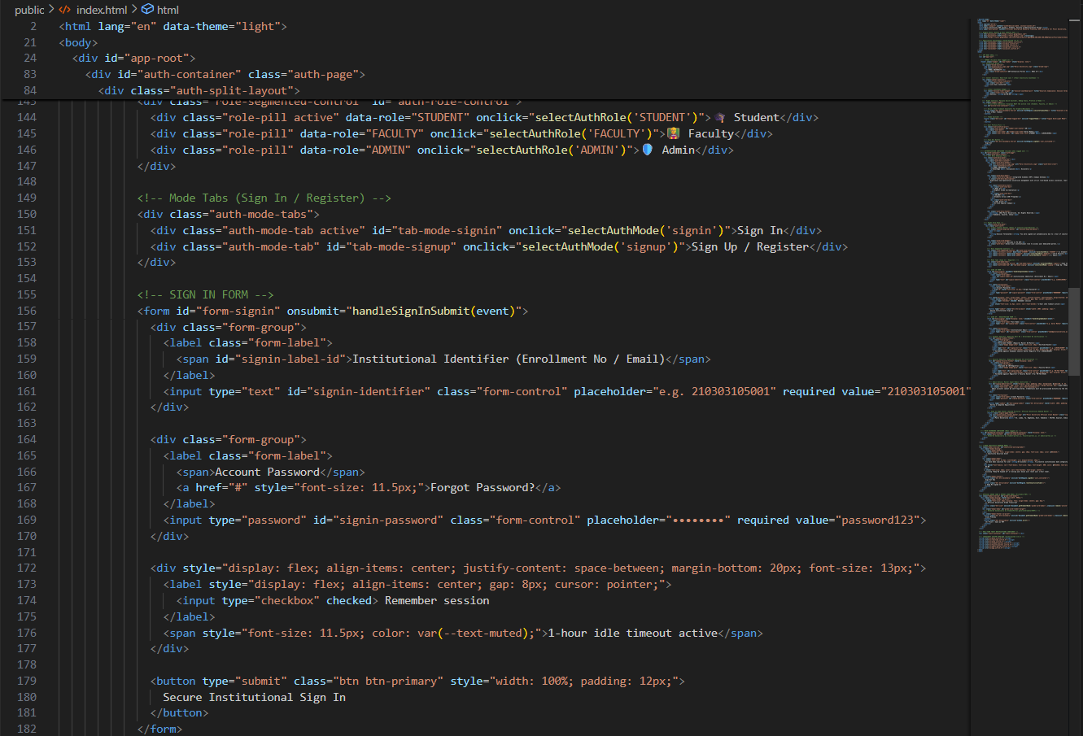
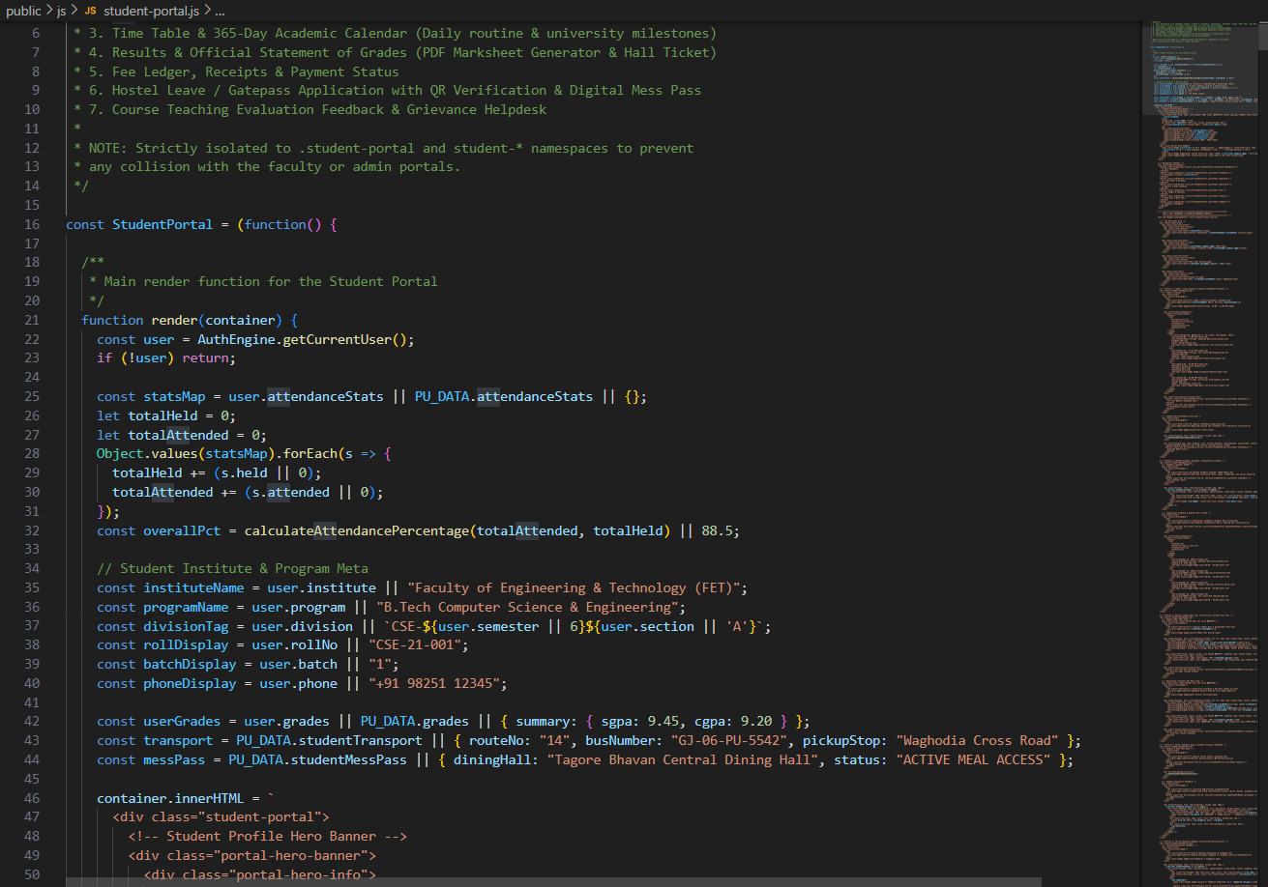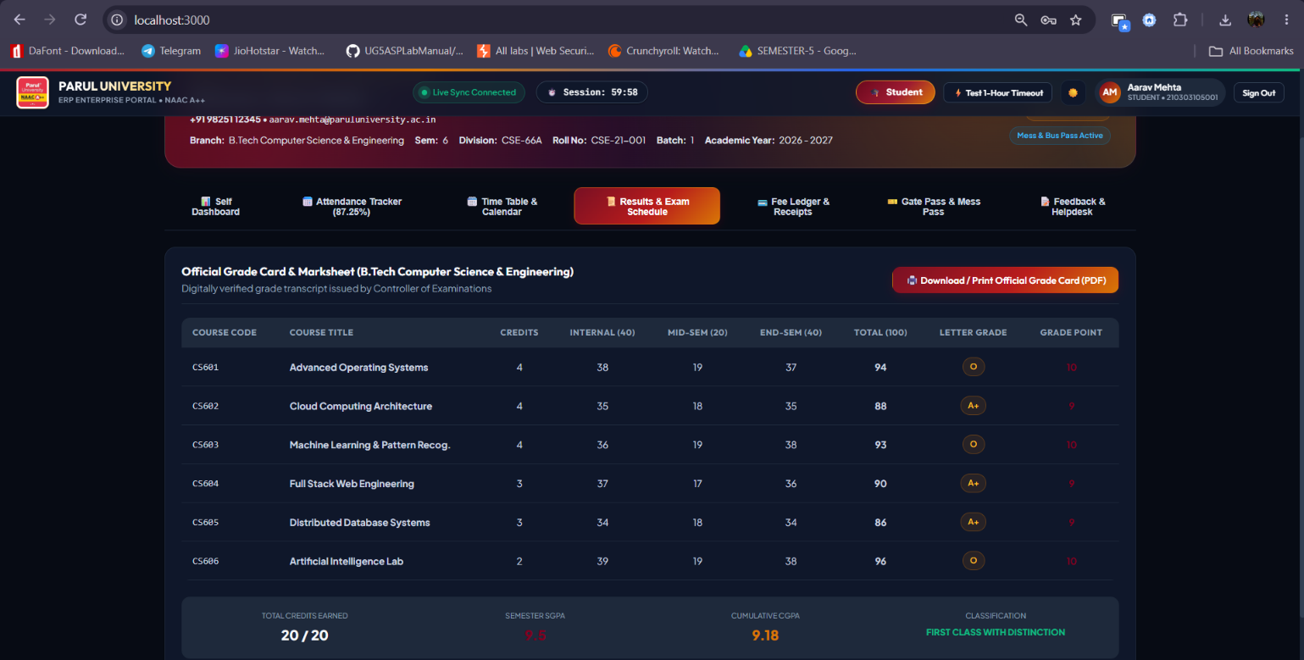

10. TESTING
SYSTEM VERIFICATION & TEST PROCEDURES
Test Case | Scenario / Action | Expected Result | Execution Status
TC01 | Sign in as Student (210303105001) | Access granted to /student/*; dashboard renders | Pass
TC02 | Faculty records and saves attendance | Student dashboard updates live; audio chime sounds | Pass
TC03 | Submit hostel outpass and approve via Faculty | Outpass flips to "APPROVED"; verifiable QR code renders | Pass
TC04 | Admin executes "Publish Semester Results" | Calculates SGPA/CGPA; unlocks Grade Card PDF modal | Pass
TC05 | Trigger "⚡ Test 1-Hour Timeout" button | Immediate token wipe; redirects to expiration notice | Pass
TC06 | Student attempts unauthorized access to /admin | Blocked by RBAC engine; redirected to unauthorized view | Pass
TC07 | Network interruption occurs | System falls back smoothly to BroadcastChannel API | Pass

11. CONCLUSION
The Smart Management Information System Portal (Parul University ERP Enterprise System) delivers a unified, modern web architecture replacing fragmented academic portals. By integrating role-based access control, responsive modular design, and sub-100ms real-time event broadcasting, the platform coordinates routine academic operations among students, instructors, and university administrators.
Expected Outcomes Delivered
- Seamless student tracking for hourly attendance, fee ledgers, and academic schedules.
- Dynamic classroom attendance submission and capstone group management for faculty.
- Automated, 1-click semester result calculation and printable PDF Grade Card generation.
- Paperless hostel outpass approvals with secure QR gate clearance.
- High security compliance through deterministic 1-hour idle session termination and live CDC audit tracking.

12. FUTURE ENHANCEMENTS
- Biometric and AI facial recognition integration for physical lecture hall attendance capture.
- Automated SMS and WhatsApp gateway integration for parents regarding low-attendance warnings (< 75%).
- Native iOS and Android mobile applications using React Native or Flutter.
- Integrated payment gateway reconciliation (UPI, Net Banking, Credit/Debit cards).
- Blockchain-verified credentials for instant online transcript verification by external employers.

13. REFERENCES
- Node.js Enterprise Platform Documentation – Runtime environment and API specifications.
- Express.js Application Framework – REST routing and middleware design.
- RFC 6455 – The WebSocket Protocol for full-duplex communication over single TCP connections.
- W3C HTML5 Web Audio API – Client-side real-time audio chime synthesis.
- MDN Web Docs – BroadcastChannel API for multi-tab cross-context synchronization.
- University Grants Commission (UGC) Guidelines – Standardized 10-Point Letter Grading and SGPA/CGPA formulas.
- Parul University Academic Regulations and Capstone Evaluation Frameworks.

Github Link To View Our Mini Project


— END OF REPORT —

